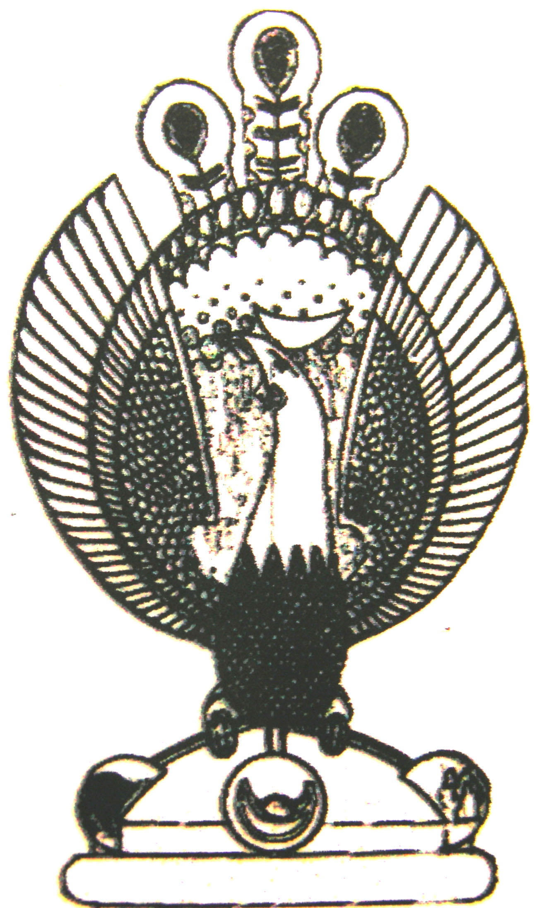

THE HERITAGE

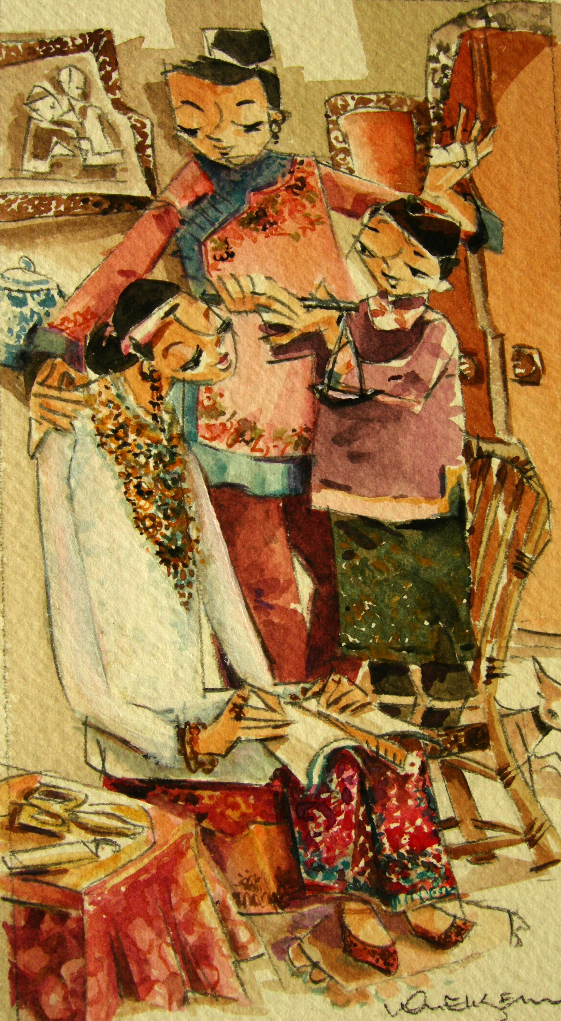
‘Chiu Thau’ ceremony
The boy who was involved in the ‘an chng’ ceremony carries a weighing scale above the bride’s head and slowly lowers it to her feet to remind her to weigh all her actions.

